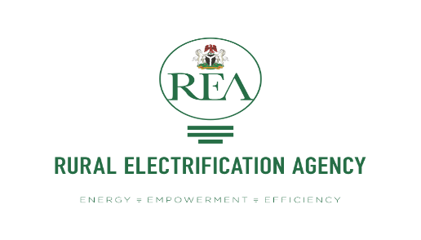

NIGERIA ELECTRIFICATION PROJECT

**TERMS OF REFERENCE**

**FOR**

**Consultancy Services for Independent Verification Agent for Results Based Finance Facilities for Solar Home Systems and Mini Grids**

**March 2019**

**Terms of Reference for**

**Consultancy Services for Independent Verification Agent for Results Based Finance Facilities for Solar Home Systems and Mini Grids Ref. No.:** **REA-NEP/C/QCBS/35/18**

1. **Background**

The Federal Government of Nigeria has applied for financing from the International Development Association a credit toward the cost of Nigeria Electrification Project and intends to apply part of the proceeds of this credit to payment under the contract for the Consultancy Services for Independent Verification Agent for Results Based finance facilities for solar Home systems and for the performance based grant program for mini grids.

Rural Electrification Agency (REA) is implementing an Output Based Fund (“OBF“) on solar home systems. OBF represents a mechanism where pre-agreed incentives are paid to companies that complete supply of products to specific identifiable users in pre-agreed locations. OBF are being used in this project as a financial incentive to private companies to create a market shift by up-scaling their operations and mitigating the market barriers, thereby increasing the availability of good quality solar products. The available funds amount to a total of 60 million USD.

A Grants Administrator firm will have the responsibility of managing the prequalification and milestones/progress tracking work for the companies participating under the OBF.

Screening of the companies and their business plans will be done by Selection Panel comprising the Grants Administrator, the Nigeria Electrification Project-Project Management Unit (NEP- PMU), and other individual(s) with a commercial and solar sector background. The overall monitoring of the project results and disbursement of the funds to the grantees will be done by the PMU.

REA is also implementing a mini grid program that will provide performance-based grants to eligible mini grid sub-projects on a rolling basis for new connections ($/end user) and provide performance-based grants (again $/end user) for new connections as part of a minimum subsidy tender. The available funds amount to a total of 150 million USD and will be disbursed upon demonstration of customer connection and satisfactory electricity service for at least 3 months. 110,000 new connections are expected to be established as part of the minimum subsidy tender, while 230,000 new connections are expected to be partly financed through the performance-based grant program. Of these, about 80,000 – 100,000 new connections are expected to be achieved in the first 24 months of the project.

1. **Objective of the assignment**

The objective of the assignment is to conduct an independent verification of claims where actual products supplied under the Solar Home Systems OBF facility are confirmed to exist and be in use by the specified end users. The verifications will serve as a trigger for payments from the PMU to the grantees with the facilitation of the Grants Administrator firm contracted under the project. The IVA will establish validity and correctness of the sales claims submitted by the grant beneficiaries for products eligible under the program.

The assignment also entails verification of customer connections and satisfactory electricity service as required for the mini grid programs (minimum subsidy tender, and performance-based grants).

**Verification framework**

1. **Verification process**

The overall verification process is summarized below:

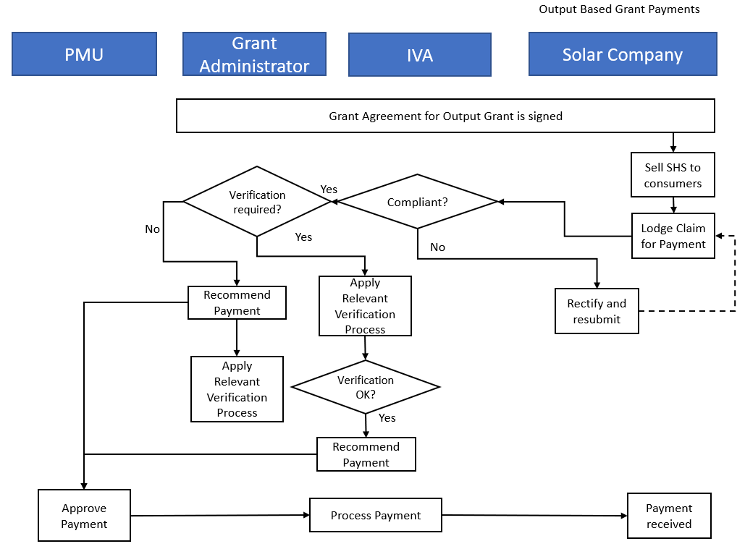

1. **Levels of verification**

The programme should be supported with several layers of monitoring and evaluation activity. The foundation of the system is the self-reporting by grantees. The following escalating, risk-based verification is suggested as a starting point for the IVA. However, the IVA candidates should specify in their proposal the recommended method of auditing based on best practices and that which balances costs with accuracy and reliability.

|  |  |  |
| --- | --- | --- |
| **Audit Level** | **Name** | **When to apply** |
| **Audit Level 1** | Telephone sample | Combination of verification of online status of systems in GSM networks (linked API) followed by phone survey for verifying sales details. |
| **Audit Level 2** | Field sample | Apply if during a Level 1 audit, more than 10% of the customer telephone numbers called cannot be contacted. |
| **Audit Level 3** | Full grantee and customer audit | If there is evidence of, or concern about recordkeeping or a significant lack of integrity in the claims data of a grantee. |

1. **Timing and triggers of independent verification**

* Claims for payment of Output Based Grants may be submitted by Grantees once each month. Claims submitted between the 1st and the 15th of that month will be processed the same month otherwise the claim will be processed the following month. The minimum number of units for a claim to be considered has been initially set as at least 200 units.
* The Claims log will include a standard report format showing a summary of the number of systems by type, and a detailed database for every system / customer with full details for audit and verification to be carried out including the system model, serial number, and full customer details. The Claims log will be completed and submitted on the Odyssey Energy Solutions online platform which will provide a customized system for both the grantees and the IVA for accessing the customer information and updating the verification status of the claims.
* New connections of the mini grid developers may be verified remotely through smart metering for claims submitted once a month. In cases where this is not possible, e.g. connections fall outside of GSM networks, the developers may submit customer acceptance receipts that confirm satisfactory delivery of electricity to new customers a percentage of which will then need to be verified through spot checks for the claim to be complete and recommendation for disbursement to be made.

1. **Independent verification activities**

The IVA will report on the verification outcomes based an agreed upon template with the REA/PMU with input from the Grant Administrator firm, which will facilitate the implementation of the solar home system component.

The following are some suggested approaches for the verification; however, the IVA may propose improvements or alternative approaches based on best practices and understanding of the sector and the operational context for this assignment.

1. **Phone Verification**

* The IVA will determine and justify an appropriate phone verification strategy and sample using justifiable sampling methods based on the relevant claims.
* Verify via call spot checks specific users identified during sampling from the consumer sales database coming from the grantee claims report.
* It is expected that grantees working with GSM enabled products in GSM accessible areas will enable linkage of their API systems with the online platform so that the live status of the customer connections can be verified remotely. This will provide an added layer of confidence and reduce some of the effort and therefore cost on the spot checks. However, additional information from the users will need to be provided.
* Verify the following during the phone calls:
  + - That the identified person is the actual user of the products.
    - That the contact and location details of the user are correct.
    - That the user acquired the stated products including the correct product model claimed by the grantee.
    - Total cost of the product to the user
    - Down payment/deposit/part-payment by end user
    - Credit and repayment period (only for loans)
    - That the user is familiar with the product specifications and their capabilities.
    - Status of payment for the products
* The IVA will carry out the phone interviews in a language familiar with the user
* The IVA will use a standardised questionnaire and make all reports in English.
* The phone verification process will highlight areas of doubt or further clarification and form part of the targets for field verification.
* The IVA may make recommendations for rejection of specific claims based on the phone verification process.
* The IVA will give an assessment of the likelihood of fraud, which may require further investigations.

1. **Field verification**

* Upon completion of the phone verification process, the IVA will proceed to undertake field verification if more than 10% of the customers called cannot be reached. The specific locations to be visited will be based on:
  + - An appropriate sampling process for field verification.
    - Specifically identified users highlighted for follow-up during phone verification.
* The IVA will carry out a field visit to a sample of customers and do interviews with customers to verify on the spot if the customers have access to energy through the products supplied.
  + - Carry out interviews in a language well understood by the user.
    - Collect answers to a set of pre-defined questions to include those from the above phone verification.
* The IVA will be required to provide GIS co-ordinates of the visited households.
* Provide photographic evidence of customers and their products.
* Customers outside of the GSM network present an added risk due to the inability for remote monitoring or verification. Hence, for to the extent that sales to these customers form part of the claim, the IVA should present a robust method of verification that minimizes the risk of fraud and collusion.

1. **Full Audit**

* If irregularities are present during the verification process of the two key methods above and the grantee fails the systems audit, the IVA wlll proceed to conduct a full audit.
* This would entail checking the grantees management and record collecting systems to determine whether there has been an error in recordkeeping or whether fraudulent activities may be taking place.

1. **Reporting, mediation, proposed adjustments**

The IVA will document the findings and make recommendations related to both the phone and field verification processes.

1. Present the findings and recommendations of the verification exercise to the Grants Administrator (GA) and to the REA PMU after concluding the verification exercise.
2. Submit, in the reports, pictures of customers and their products taken during the Field Verification stage (if applicable).
3. The IVA will be required to propose adjustments to the incentive claims based on verification findings. This includes increasing, decreasing or removing altogether specific claim items or categories of claim items. The IVA will thus be responsible to report errors or omissions in the claims and provide recommendations on how to deal with them. The recommendations of the IVA on the claims are not binding to the GA and PMU, but will be important in assisting these two entities to make informed decisions.
4. The IVA will propose the percentages for thresholds for deferring/suspending a claim, based on the risk review, and taking into consideration progress made in the activities.
5. The IVA will provide an assessment of the likelihood of fraud which may require further investigations
6. The IVA will work closely with Odyssey Energy Solutions to integrate monitoring and verification processes into the online platform.

Summary of key deliverables

The IVA will submit a verification approach inception report to include the verification approach to the GA and PMU, which will cover:

* Sampling size and spot checks to be done through remote verification (monitoring of live systems, phone calls, etc.)
* Phone and field questionnaires for the grantee’s claimed customers
* The questionnaires and reporting format will be reviewed and jointly pre-agreed with the GA and PMU, before implementation
* Verification completion labelling and progress tracking to be done through the online platform Odyssey Energy customized site
* Quarterly reporting to the GA and PMU on the total number of claims and verifications completed for each claim

1. **Quality and performance review**

The NEP PMU shall be conducting periodical quality and performance review of the IVA processes, operations and outputs

1. **Duration of Assignment**: The initial phase of the assignment is 24 months with the possibility of extension upon satisfactory performance
2. **Qualification and Experience of Firm**

The consultancy firm with the following qualifications are invited to participate in the independent verification agent assignment:

1. The IVA will be a top tier consulting or audit firm with a minimum of five (5) years operational existence as an organization.
2. Minimum of two (2) similar assignments in the last five (5) years
3. Capacity to verify transactions:

* Demonstrated experience in verification exercises, socio-economic studies and field /on-site studies
* Proof of accounting, audit and finance background will be essential
* Experience in organizational and project assessments including systems review
* Past roles in project transaction verification will be an advantage

1. Ability to deploy resource persons in multiple rural locations if and as necessary
2. The persons carrying out the tasks should be fluent in local languages and English
3. Experience with the rural economy through past assignments. Familiarity with rural energy interventions will be advantageous including engagement with energy product or service providers
4. Excellence in computer skills is mandatory for all proposed staff
5. Ability to deploy a robust data collection and management system with capacity to track GIS coordinates for the field visits evidence of similar deployment in the past will be essential
6. The Consultant shall provide the following experienced personnel to carry out the assignment with the following minimum qualifications:

*Coordinator:*

The Coordinator should have at least a higher education degree in Accounting and Auditing, eight (8) years of experience and be able to show leadership skills for backing the team and reporting clearly on the outcomes for that period.

*Senior Auditors:*

Two Senior Auditors with at least a degree in Auditing or Accounting and five (5) years of experience in similar activities. The Auditors will primarily use desk/remote verification methods using the submitted claims on the online platform and the systems’ live status (where applicable). They will liaise and work with the field resource team as applicable.

*Field verification specialists:*

The deployment of resource specialists in the field will depend on the escalating method of verification and need for physical verification visits (in cases where remote verification is not sufficient and e.g. for sales areas with no GSM coverage). The candidate firm should propose this based on the scope and the envisaged level of effort (see below) for this assignment.

The team will need to demonstrate clear capacity for managing risk in the field related to all aspects especially on integrity and plan for preventing collusion possibilities.

1. **Budget and Level of Effort**

The applicant will propose, in its IVA role application, fee rates based on staff expertise levels. The fee structure proposed should indicate the level of each resource person and indicate support staff, if any, and associated administrative and reporting costs.

It is expected that as part of the first phase of the assignment (24 months) the IVA will make monthly verifications for approximately 12 solar companies on average. However, the number of actual verifications and the precise workload will depend on the level of participation by the private sector and meeting of the eligibility criteria of the program.

As part of the financial proposal, the firm should also propose an average fee amount for a single monthly verification in line with the level of effort required from its resource persons (defined above)

The workload is expected to be lighter in the initial stages of project implementation, but ill gradually increasing during the implementation period.

Consultant will be selected in accordance with the Consultants Quality and Cost-based Selection (QCBS) set out in the Procurement Regulations for IPF Borrowers dated *July 2016 Revised November 2017 and August 2018* available on [www.rea.gov.ng](http://www.rea.gov.ng)